Data Exploration using SQL

**1] What was the total quantity sold for all products?**

Query: select product_details.product_name, sum( sales.qty) as sales_count from sales inner join product_details on sales.prod_id=product_details.product_id group by product_details.product_name order by sales_count desc;

**Output:**

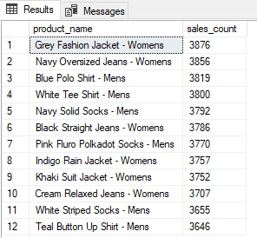

**2] What is the total generated revenue for all products before discounts?**

Query: select sum(price*qty) as without_discount from sales;

**Output:**

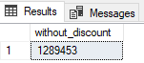

**3] What was the total discount amount for all products?**

Query: select sum( price*qty*discount)/100 as total_discount from sales;

**Output:**

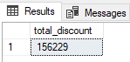

**4] How many unique transactions were there?**

Query: select count(distinct txn_id) as uni_txn from sales;

**Output:**



**5] What are the average unique products purchased in each transaction?**

Query: with cte_tran_prod as

(

select txn_id, count(distinct sales.prod_id) as uni_prod from sales

group by txn_id

)

select avg( uni_prod) as avg_uni_prod from cte_tran_prod;

**Output:**

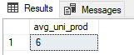

**6] What is the average discount value per transaction?**

Query: with cte_disc_txn as

(

select txn_id, sum(price*qty*discount)/100 as total_disc from sales

group by txn_id

)

select avg( total_disc) as avg_disc_txn from cte_disc_txn;

**Output:**

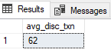

**7] What is the average revenue for member transactions and non-member transactions?**

Query: with cte_rev_member as

(

select member, txn_id, sum( price*qty) as revenue from sales

group by member, txn_id

)

select member, round(avg(revenue),2) as avg_rev from cte_rev_member

group by member;

**Output:**

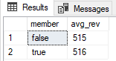

**8] What are the top 3 products by total revenue before discount?**

Query: select top 3 product_details.product_name, sum(qty*sales.price) as without_discount from sales inner join product_details

on sales.prod_id=product_details.product_id

group by product_details.product_name

order by without_discount ;

**Output:**

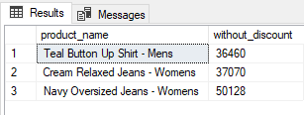

**9] What are the total quantity, revenue and discount for each segment?**

Query: select product_details.segment_id, product_details.segment_name , sum( sales.qty) as total_qty ,

sum( sales.qty*sales.price) as total_revenue, sum( sales.qty*sales.price*sales.discount)/100 as total_discount

from sales inner join product_details

on sales.prod_id=product_details.product_id

group by product_details.segment_id, product_details.segment_name

order by total_revenue;

**Output:**

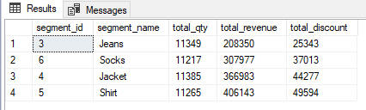

**10] What is the top selling product for each segment?**

Query: select top 5 details.segment_id, details.segment_name, details.product_id, details.product_name,

sum( sales.qty) as prod_qty from sales inner join product_details as details

on sales.prod_id=details.product_id

group by details.segment_name, details.segment_id, details.product_name, details.product_id;

**Output:**

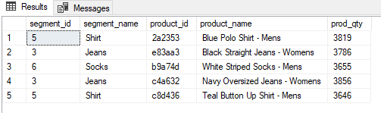

**11] What are the total quantity, revenue and discount for each category?**

Query: select details.category_id, details.category_name,

sum( sales.qty) as total_qty, sum( sales.qty*sales.price) as total_revenue, sum( sales.qty*sales.price*sales.discount)/100 as total_discount

from sales inner join product_details as details

on sales.prod_id=details.product_id

group by details.segment_name, details.category_id, details.category_name

order by category_name;

**Output:**

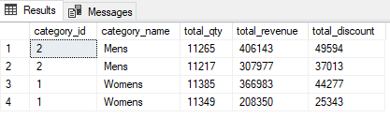

**12] What is the top selling product for each category?**

Query: select top 5 details.category_id, details.category_name, details.product_id, details.product_name,

sum( sales.qty) as prod_qty from sales inner join product_details as details

on sales.prod_id=details.product_id

group by details.category_name, details.category_id, details.product_name, details.product_id

order by prod_qty desc;

**Output:**



